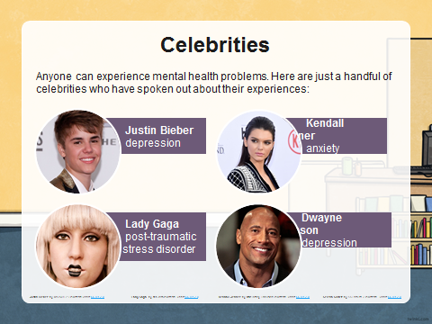
Mental Health & Well Being
Mental health issues are more common than you think – they can affect people from all walks of life, whether rich and famous or an ordinary Joe Bloggs.

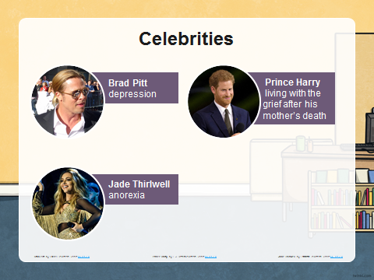
It takes courage to acknowledge something maybe wrong and ask for support. The key is to know there is always someone there who is willing to help.

